**TASK-09**

Sales Commission Calculator

**EXPLANATION:**

The program asks the user to enter his / her sales for the week and then calculates the commission of for each person plus his salary. The program doesn’t take the negative values or the character as an input, it gives the error and returns the user to the input value.

**INPUT:**

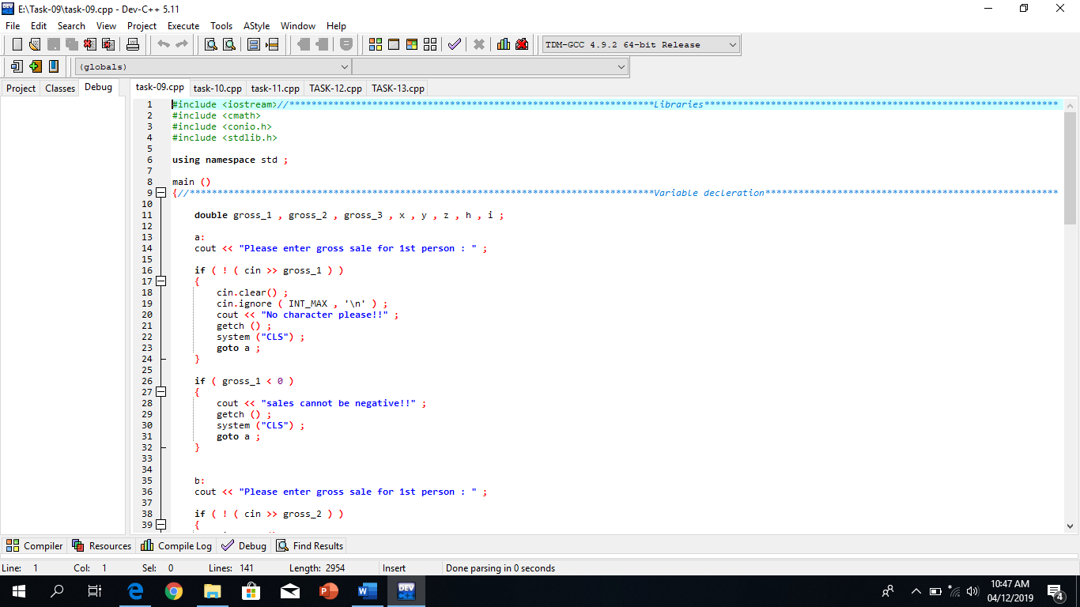

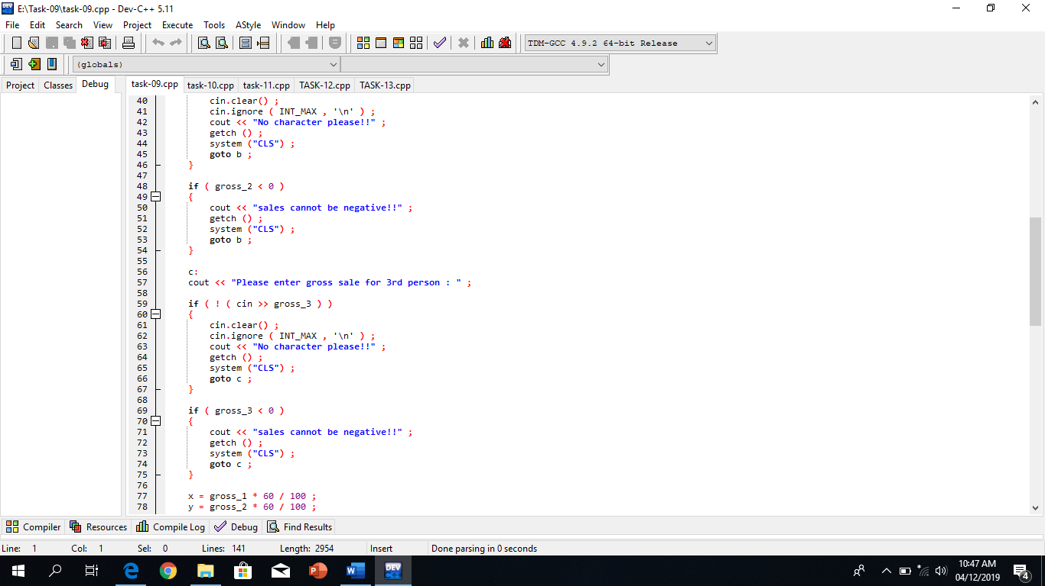

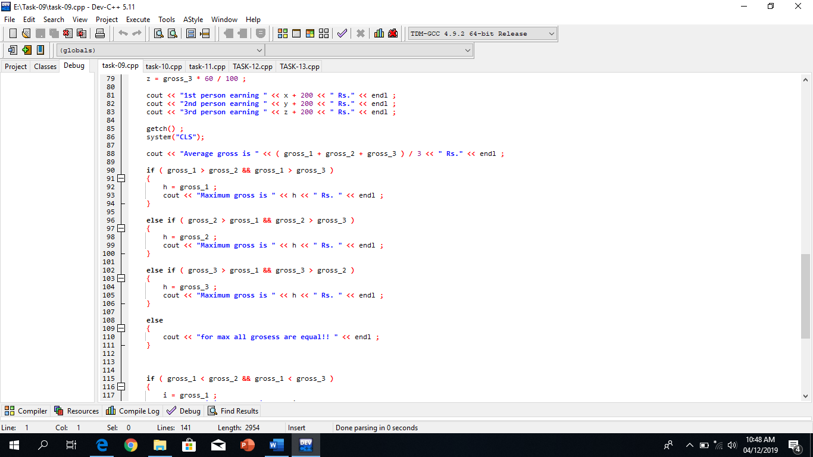

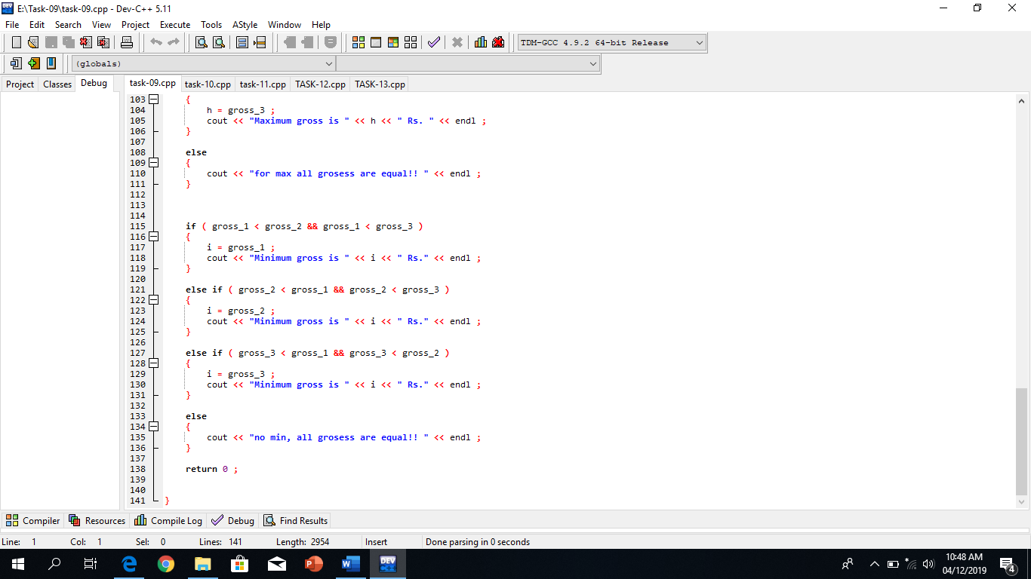

**OUTPUT:**

